Skogsmulle Symposium: 60th Anniversary Celebration
3-7 August 2017

BOOKING FORM

Please read the form below carefully and make sure each section is completed in full. Please return to us within three weeks of receipt to confirm your booking.

PARTICIPANT/S
Name | Name of school / organisation | Address of school / organisation | Telephone number | Email
TOTAL COST:

PAYMENT
Deposit of £100p/p is required to confirm booking and final payment will be requested on 1st June 2017. Early Bird pricing expires after 30th April 2017. Please tick your payment method and complete the table below. If a deposit is not able to be paid within 3 weeks of submitting booking form, please inform us and indicate when the deposit is likely to be paid.
School or Organisation:
Name, address and email to send invoice to |  | Quote order number or PA
ONLINE
You can pay a deposit online at www.igniteup.co.uk/events/

Cancellation will only be accepted up to one month prior to the conference to enable us to offer the opportunity place to others. See Terms and Conditions of Booking below.

Signature authorising staff member: __________________________

Date:__________

Please complete over page

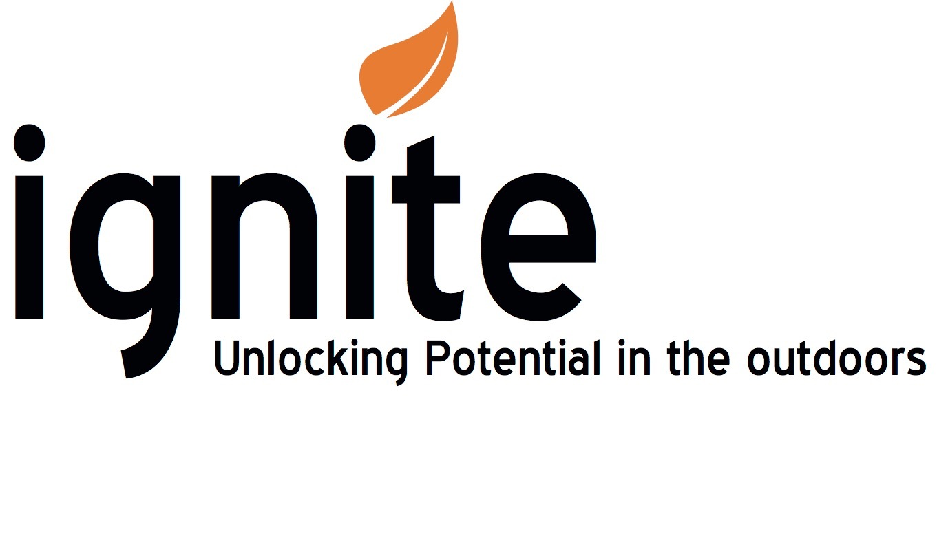
SPECIFIC NEEDS (i.e mobility and learning)
Please let us know of any specific needs for all participants. Please let us know as much detail as you can so that we can adapt and prepare where necessary or discuss with you to ensure you have a successful and enjoyable day. If there are no specific needs please indicate as N/A.
Name:
Name:

DIETARY REQUIREMENTS
A series of meals will be available throughout the Symposium . Please specify if any participant has dietary requirements. If there are no dietary requirements please write ‘none’.
Name:
Name:

WORKSHOP CHOICES
Workshop choices will be announced in Spring 2017.
PACKAGE CHOICE
Please confirm how many individuals are taking which package (if individuals are coming on different packages, please initial the choice e.g. A - 1 MW B - CJ C - GH | A  5 nights and London transfer from central point and time on 2/8/17 | B  4 nights, won travel and conference | C  Conference only | D  Training & Conference | E  Culture Excursion

ACCOMODATION (Accommodation is first serve basis and will be either on site at Dare Valley Hotel, On site Bell Tent, Clamping or a local B&B with shuttle bus transport provided)
 | Dare Valley Hotel (4 to room) | Dare Valley Glamp (4-6 share) | B&B (Double rooms) | I will arrange my own

Joining instructions will be sent nearer the time with details about timings, what workshops you are attending and what to wear etc.

Return to:

Ignite UP

Dare Valley Park

CF44 7RG

info@igniteup.co.uk

Skogsmulle Symposium: 60th Anniversary Celebration
3-7 August 2017
Terms and Conditions of Booking

Course Booking
- On receipt of a fully completed booking form to Ignite UP with a deposit, the booking is then confirmed (i.e. we will maintain that booking for the customer for as long as required). Booking forms can be downloaded for completion from the website.
- Ignite UP requires the signed confirmation booking form[s] to be returned within 3 weeks of sending the information to the customer.
- If the booking form and payment details are not returned within the stated 3 weeks Ignite UP reserves the right to cancel the provisional booking and offer places to other participants.

Balances / Payment
- For all customers an invoice will be issued for outstanding amounts in June 2017 or a cheque payable to Ignite Unlocking Potential Ltd will be paid in when received. Direct Payment in advance is available via www.igniteup.co.uk

Cancellations
- Cancellations will only be accepted in writing.
- The date of the cancellation will be the date when the written cancellation is received by Ignite UP. Cancellation of a booking will result in the following:-

Over 1 month before - the full course fee will be returned
One month to one week before - the full course fee will be retained (to cover administration and co-ordination time).
No written notification received - 100% of the fee will be retained.
Failure to arrive - 100% of the fee will be retained.
Leave partway through - 100% of the fee will be retained.

Postponement of Conference due to bad weather or other special circumstances
In certain circumstances the Conference may be postponed, in which case Ignite UP will make every effort to find a suitable date for the course to take place at a later date. The fee for the original course will be used to secure the booking.

Ignite UP in its absolute discretion may decide not to enforce any one or more of the terms or conditions of this agreement in which case this shall not be a waiver of them or of the right at any time to subsequently enforce all terms and conditions of this agreement.

Signing the Confirmation Booking Form is an acceptance of having read and agreed these Terms and Conditions.

